7.1:
word = input('Please enter your word: ')
compressed = ''
current = word[0]
count = 0
for x in word:
if x == current:
count += 1
else:
compressed = compressed + ' ' + current + ' ' + str(count)
current = x
count = 1

compressed = compressed + ' ' + current + ' ' + str(count)

print(compressed)

7.2:
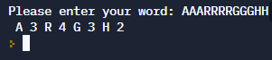

7.3:
